Reynoldsburg Lodge #340

7350 Broadwyn Drive

Reynoldsburg, Ohio 43068

(614) 866-8179

<http://www.mason340.com>

Stated Meeting: 1st Tuesday 7:30PM

September through June

Special Meetings: 3rd Tuesdays and as called by the WM

Lodge Officers

|  |  |
| --- | --- |
| WM – Sam Cohen | (614) 517-5156  [samuel.cohen@mason340.com](mailto:samuel.cohen@mason340.com) |
| SW – Michael DuMolt | (614) 312-6304  [gmdumolt@gmail.com](mailto:gmdumolt@gmail.com) |
| JW – Adam Lappert | [acl910912@gmail.com](mailto:acl910912@gmail.com) |
| Sec – Etienne Roserie | (614) 632-9186  [emroserie@gmail.com](mailto:emroserie@gmail.com) |
| Treas – Harold Davis | [treasurer@mason340.com](mailto:treasurer@mason340.com) |
| LEO – Ken Cohen | [ken.cohen@mason340.com](mailto:ken.cohen@mason340.com) |

Lodge Calendar

**July**

1 Fireworks and fundraising at Civic Park 6 to 10pm

4 Parade 9am

5 Stated Meeting

16 Brother’s Night Out- Clippers Baseball Game

30 Breakfast

**August**

2 Stated meeting

20 Table Lodge

27 Breakfast

TBD Clean up at Lodge

TBD Brothers Night Out

**September**

6 Stated Meeting

TBD Brother Night Out

TBD Inventory

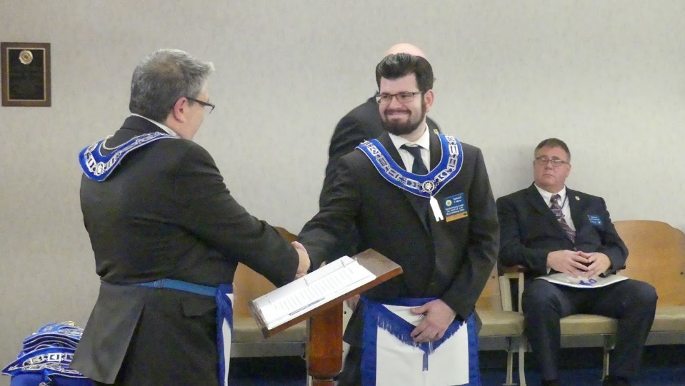**From the East**

**WM Samuel Cohen**

Hello Brethren,

We are approaching our summertime and I am sure everyone has plans for the 4th of July, vacation, beach, and other fun things. The lodge has lots of activities coming up that we would love to have you participate in if you can. We have several fundraising events coming up and some work around our building that needs to be done.

As most know that our lodge normally goes dark during July and August but this year we are going to hold our stated meetings with permission from the Grand Master’s edicts. The reason we are meeting during summer is that we still have a lot of work to do and petitions to process. Not only that to be able to get the process for any brothers who want to do One Day Class that our Grand Lodge is planning. So please keep an eye out on the date that I will be sending out later in the year.

As we go forward to our year, I have set out to allow each officer in the line to be in the East acting as Worshipful Master running the meeting because there is nothing better to be able to be comfortable and knowing what need to be done before becoming Worshipful Master during their year. If any new members that want to start stepping up in different officers stations, please let me know and I can be able to make it happen.

If you have any questions, please feel free to contact me.

**Words From the West**

I am sure you have noticed that I like to start “Words from the West” with a quote. “Know thyself, you wear aprons – good, you wear lapel pins – nice, you wear Masonic hats – fine, you wear Masonic rings – nice. All these are no proof of you being a Freemason. The truth is that it’s only when you live the tenets and the principles of Freemasonry on which it was founded, you can be known as a Freemason.” Brother Adeshina Bada

There was a time in my past when I removed my ring, I stopped going to meetings, and I did not mention to others I was a Freemason. Why might you ask? It was because I felt guilty and ashamed of the actions I had taken in my previous career. I did not consider myself to be of good moral character. So, I separated myself from the Fraternal Order I valued and treasured.

It was during that time in my life a couple of brothers reached out to me and ask, “Brother DuMolt, we haven’t seen you in a while! What’s going on? How can we help?” I am here to tell you, these brothers brought me back to Freemasonry. It was wonderful to sit down with someone I could talk to and know that it was safe and healing.

One of them, also being a veteran could relate to my struggles and hesitations. I am a better man today simply because, they reached out to me. I ask you, if you know a brother that has not been to lodge in a while, to reach out to them. Let them know you care and that you are there to listen and help as best you can. After all, brethren, it is one of the principles of our profession, to befriend and relieve every brother who shall need your assistance. What can we do as their brothers to bring back to the lodge and be an active part of the most ancient and honorable fraternity? We cannot serve mankind and our communities without active participating brethren. I ask you, spread the word: “Let’s fill the seats.”

In addition, I know for myself that I get excited and have warmth in my heart when I see a brother in lodge that I either have not seen in a while or have never met before. It is like a small emptiness is filled when I shake their hand, I cannot help but smile and feel good, “let’s fill the seats.” Also, think back to the time when you were at a Masonic event, you saw a family member or friend. Were you not proud to be a part of the fraternity? Come out and get that feeling again, it will give you a small feeling of satisfaction.

Practices are on the 2nd and 4th Tuesdays, excluding any specials for degrees called by the Master. These practices are a wonderful time for enjoying the fellowship of our fraternity. Please, join us for the JOY and FUN of lodge.

An important additional note: If you have not already done so, please visit Grand Lodge webpage to either register and/or update your profile

https://oh.grandview.systems/public_lodges/landing_page

I can be reached at 614-312-6304 or gmdumolt@gmail.com for any reason. I am here for you, our brethren, and our lodge. Be of one mind, live in peace, and may the God of love and peace delight to dwell with and bless you.

You can also visit our website calendar for future practices information

https://www.mason340.com

Thank you, Brethren! We look forward to seeing you all. “Let’s fill the seats!”

**RENT THE LODGE**

Got a family gathering? Office or Birthday party?

Rent Godfrey Hall and our kitchen for your function.

$50 for Godfrey Hall for members of Reynoldsburg Lodge & Clients with Contracts

$25 additional charge for kitchen use

$75 for Godfrey Hall for non-members

Daily Rental/Use agreement required

Contact a Trustee for details

reservations@mason340.com or

text 614-496-5444

**Calling For Topics and Speakers.**

Brothers, please submit your recommendations for Topics and Speakers to [LEO@mason340.com](mailto:LEO@mason340.com) . Suggestions anytime!

**Paying Your Dues/Sponsoring the Floor or any other Payment**

http://bit.ly/2msdk5e

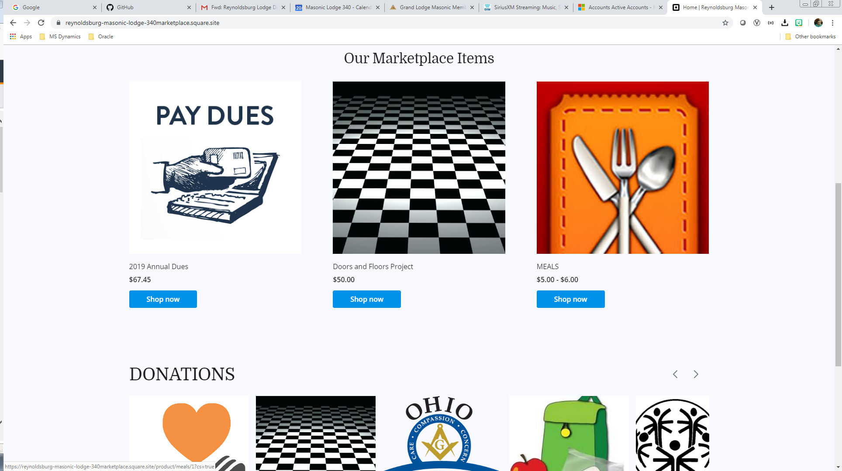

Brethren: WBro Harold Davis, Treasurer has set up a website where you can pay your dues, donate to the newly renovated floor, or make any other payment to the lodge. Just type in the link above (and below) and enter your information. The site charges a small fee to cover administrative expenses and the rest comes to the lodge. Or you can pay your dues with your normal check sent by “snail” mail (or even just come to lodge to pay your dues). You can also donate to Masonic charities through the same process.

There are about several dozen donation opportunities left for those members who want to support the recent capital improvements by adding their name or a short message to a representation of the newly installed mosaic pavement in the center of the lodge room. Squares are available at $50 each. Make your check payable to Reynoldsburg Lodge 340, F&A.M. and print "Doors & Floors" in the memo line and mail them to the Secretary.

**Trustees Corner**

As we head into the summer, we turn our focus on fundraising and planning for our next Masonic year. We also look forward to incorporating our newest members into our current culture and encouraging them to exercise those leadership qualities that will enable our lodge to continue to be relevant to the Reynoldsburg community and to grow freemasonry. We consider the purpose of our fundraisers to be not only to make money for the lodge and the charities it supports but also to strengthen our fraternal bonds and improve the interpersonal skills that make us better men.

The fundraising schedule this year is more aggressive than in past years since the need to improve ventilation in our kitchen is necessary to meet fire prevention codes. We are fortunate to be able to return to the Reynoldsburg Tomato Festival this year as a non-profit vendor of our traditional funnel cakes. Here is the schedule and a short description of each event.

1. Friday, July 1, 2022, 6p to 10:30pm, Civic Park, 6800 Daugherty Dr., Reynoldsburg

Independence Day Celebration. This is the annual fireworks event and includes several food trucks in Civic Park. The lodge is the exclusive seller of funnel cakes. Event Chair:

Samuel Cohen (614-517-5156)

2. Thursday - Saturday, August 4-6, 2022, 4p to 11pm (Thu &amp; Fri), 11a-10pm Sat., Huber Park, 1640 Davidson Dr., Reynoldsburg Tomato Festival. Participating after 3-year break.

The lodge will be selling funnel cakes. Event Chair: Christopher Diaz (518-227-8851)

3. Saturday, August 6, 2022, 8a-1pm, Aladdin Shrine Center, 1801 Gateway Circle, Grove City. Columbus Ham Radio Fest. This is the lodge’s 4th year participating in this one-day event as the exclusive food supplier to festival attendees. We are investigating securing a commercial food truck and will sell coffee & donuts.

Event Chair: Michael DuMolt (614-312-6304)

4. Wednesday - Saturday, August 31- September 3, 2022, 5p to 11pm (Wed-Fri), 10a-10pm

Sat., Lion’s Park, 4901 Chautauqua Blvd., Millersport, 75th Millersport Sweet Corn Festival.

Selling Pulled Pork, Sloppy Joe Sandwiches, and Jumbo (1/4 lb) Hot Dogs with drinks from Booth C-15. This is the lodge’s 8th year participating in this well-known annual festival. Concerts to be held all four nights.

Event Co-Chairs: Chris Diaz &amp; Dave Gubanc (518-227-8851; 614-496-5444)

5. Friday, October 1, 2022, 4p-8:30pm, Huber Park. Blues & Brews Fest.

Reynoldsburg lodge will be the exclusive vendor of funnel cakes. Celebration of live blues music, craft beer, great food, and fun family activities.

Event Chair - To be determined.

As temperatures rise outside, it is imperative that we keep our eyes on the temperatures inside our lodge building. Regular maintenance was performed on both systems in late May, and they should be able to service our needs as long as they are operated responsibly. It is important that thermostats be reset to 80 degrees, the fans set to automatic, and the window blinds closed when leaving the building. This will ensure that the kitchen refrigerator and freezer do not overwork, and we won’t be purchasing electricity we don’t need.

As we encounter warmer weather, please keep in mind that our dining room and kitchen are available for anniversary and birthday parties and family reunions. We also have free Wi-Fi. Our daily rental rate is still $50 for lodge members and members of our lessees. Details on how to arrange daily rentals for any family or community event can be found elsewhere in this issue of the Trestleboard.

As always, we remain in service to the Great Architect of the Universe, our brothers, and their families.

Christopher Baer, Chair Exp. 2023  
614-866-6593  
cbaer@insight.rr.com

Dave Gubanc, PM Exp. 2022  
614-496-5444  
david_gubanc@att.net

Ben Okwumabua, PM Exp. 2024  
614-735-2017  
3enok57@gmail.com

**You Should Have Been There**

Photos from the Lodge

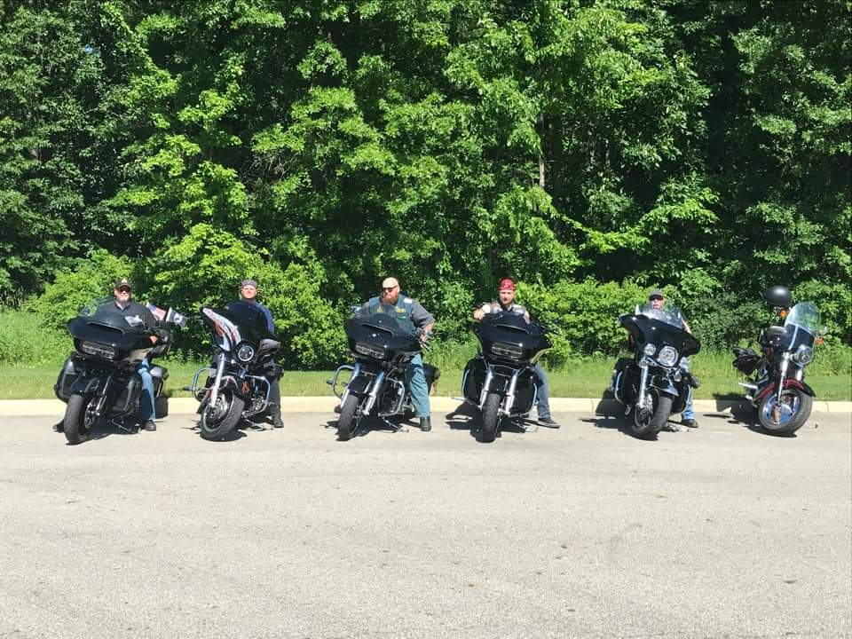

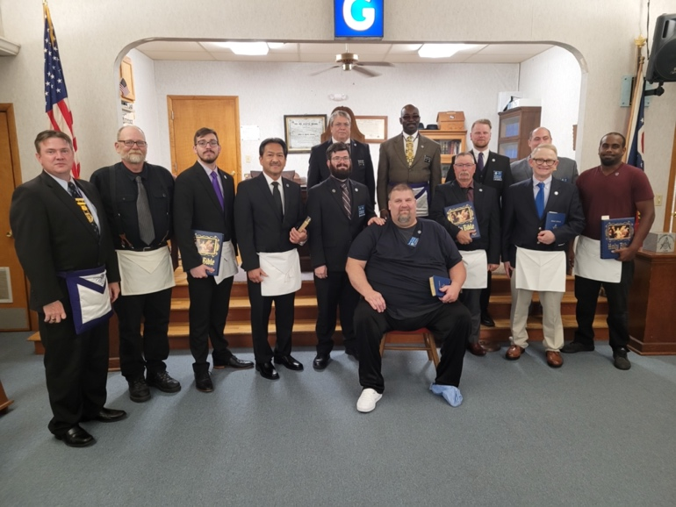

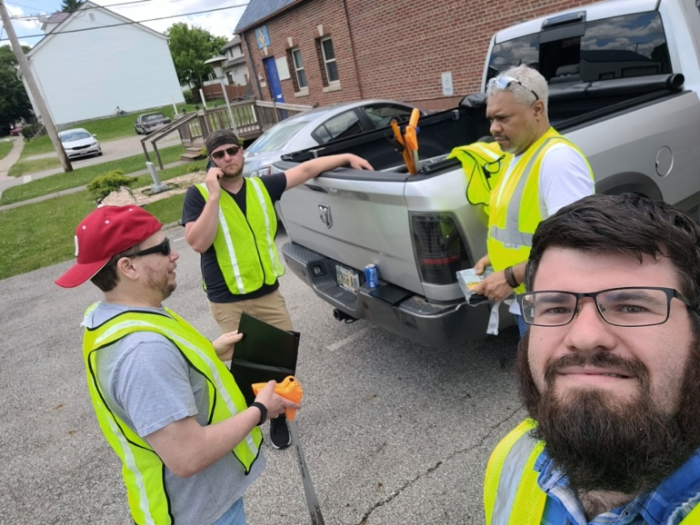

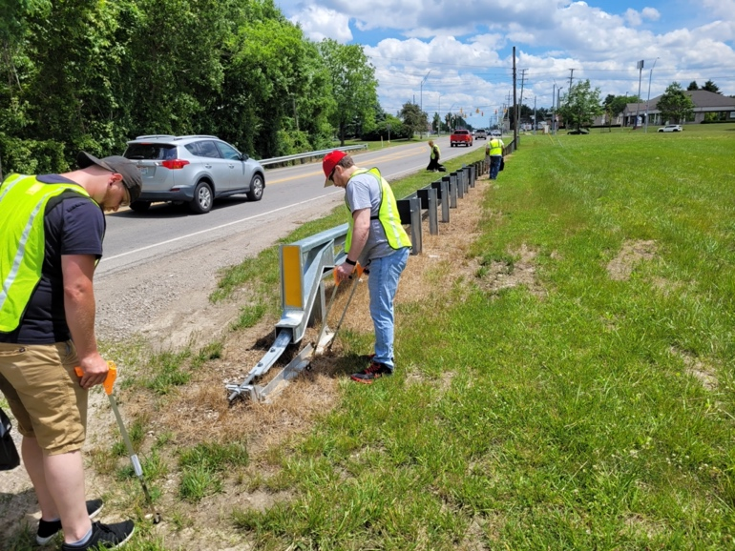

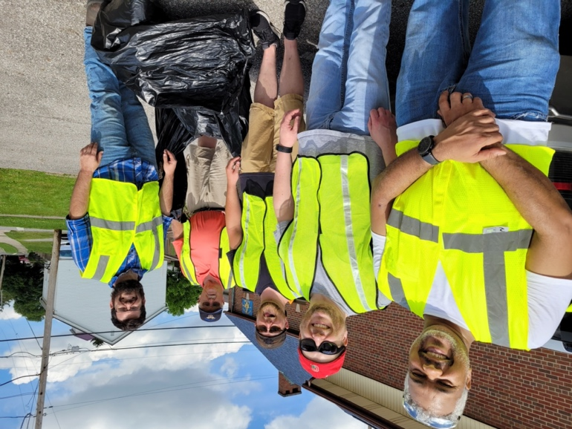

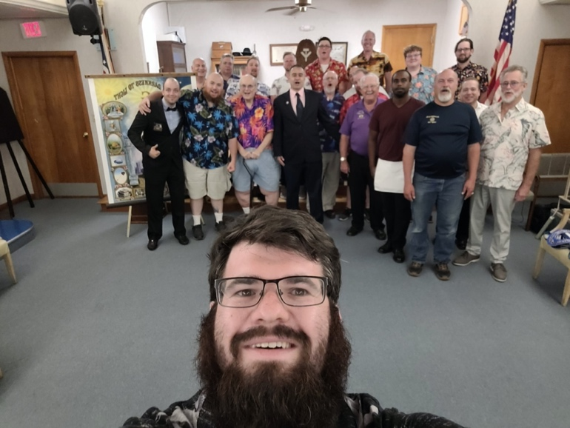

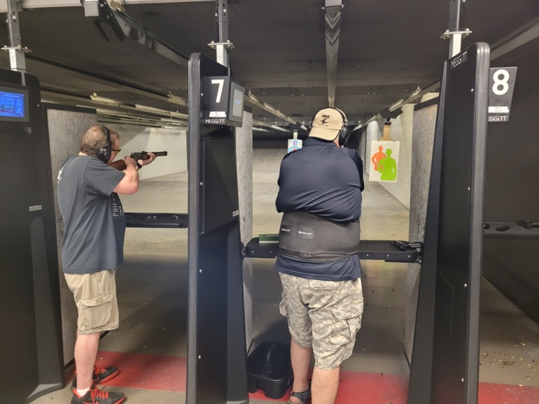

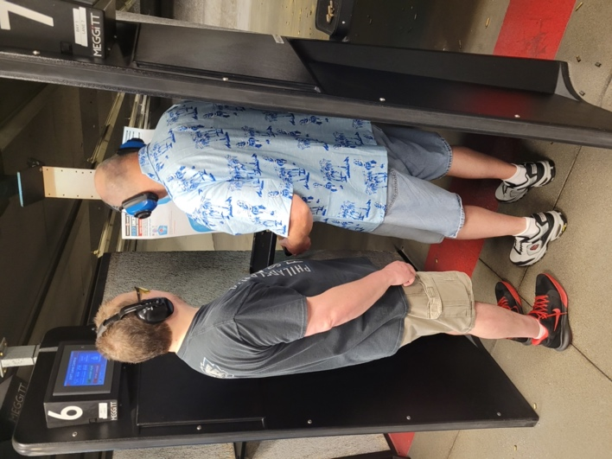





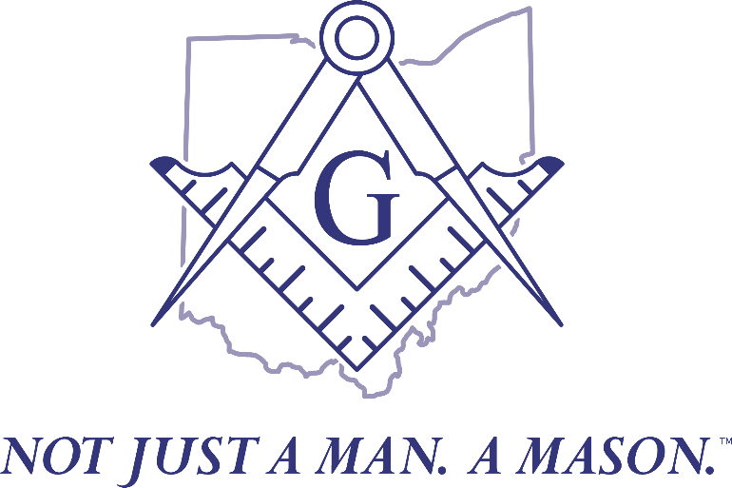

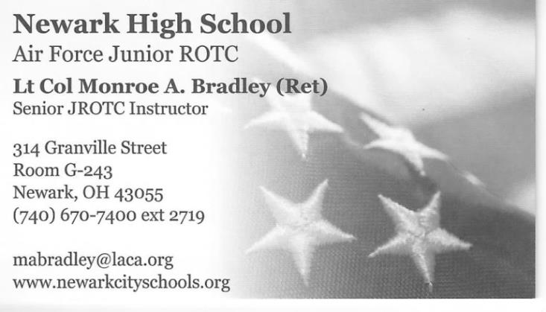

PRSRT STD  
U.S. POSTAGE

**PAID**

COLUMBUS, OH

PERMIT #2609

REYNOLDSBURG LODGE 340 F&A.M

P.O. BOX 624

REYNOLDSBURG, OH 43068

